Create oData using SEGW

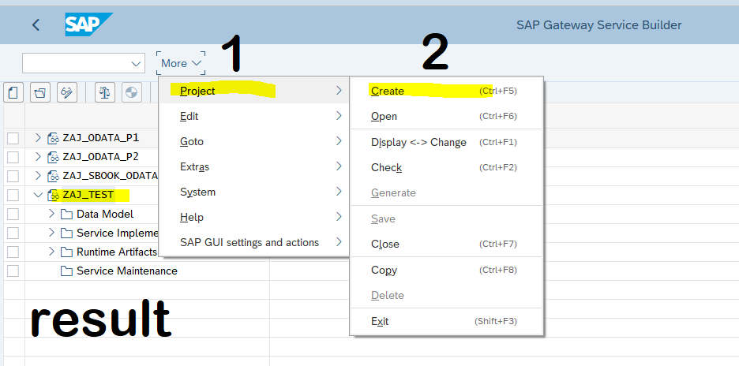

Right click on Entity set and click create

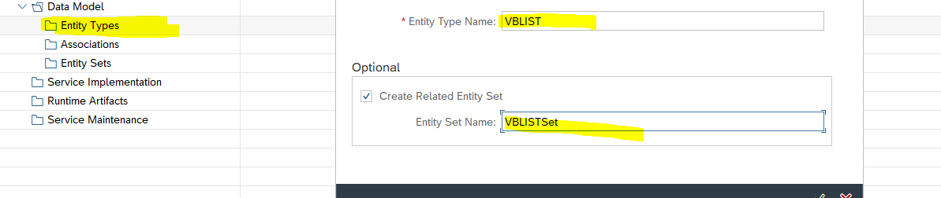

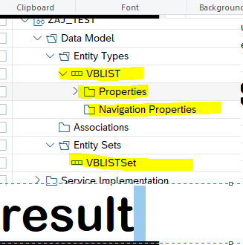

click on properties and create a structure

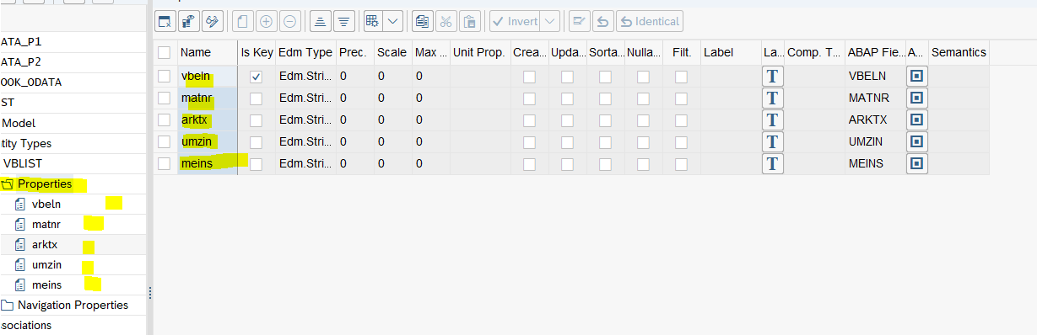

Save and generate



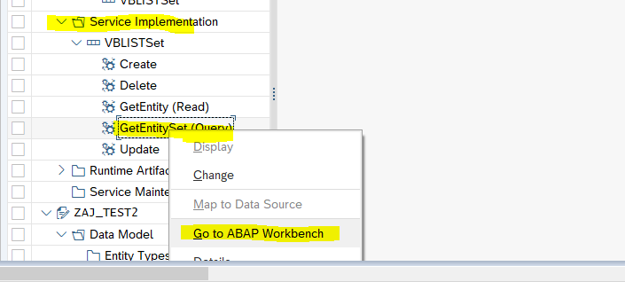

Redefine the **get_entityset**

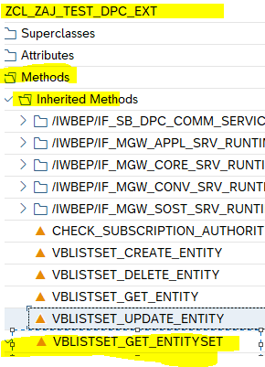

Get the data and pass it to entityset internal table

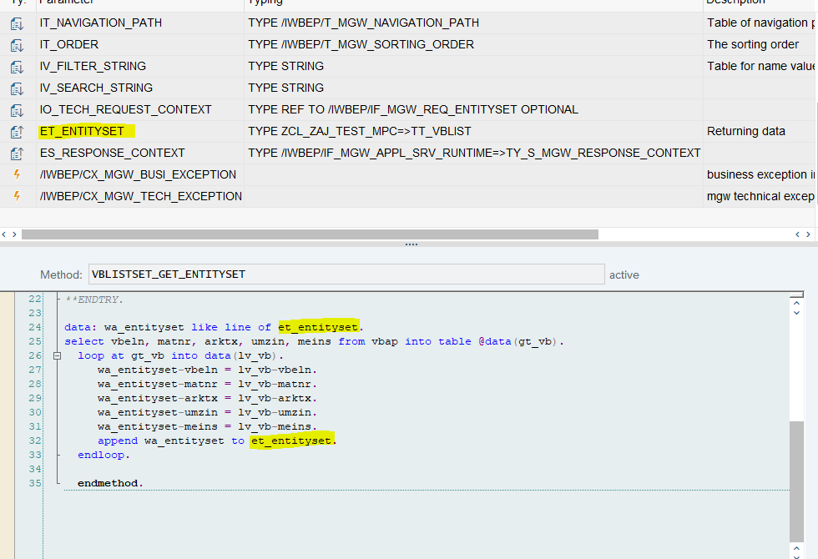

Next Is create a service using **/n/IWFND/MAINT_SERVICE** tcode